Engineering Week

What is E-Week?

In 1951, the National Society of Professional started Engineers Week (E-Week) to call attention to the positive contributions engineers make to society. E-Week is celebrated the week of George Washington’s birthday because President Washington is considered the nation’s first engineer. E-Week is also a catalyst for outreach across the country to kids and adults alike. E-Week is part of many corporate and government cultures and is celebrated on every U.S. engineering college campus.

What has the USPTO done in the past to celebrate E-Week?

In 2010, the USPTO Chapter of the National Society of Black Engineers (NSBE) spearheaded the first E-Week celebration. Dr. James West of Johns Hopkins University keynoted an event, which also included a paper airplane competition.

In 2011, realizing that E-Week is an ideal time to outreach to local students, the PTO Chapter of the Society of Hispanic Professional Engineers led the effort in bringing in local area students to expose them to the work of the USPTO and encourage the students to continue their education, especially in the area of science and engineering. Since then, the E-Week program has focused on bringing in students. All the Affinity Groups and the Patent and Trademark Office Society (PTOS) have worked together in hosting the students for the E-Week program.

In 2011, the theme was “Green Technology” and the students built model houses, with working solar panels, to create a “Green City.”

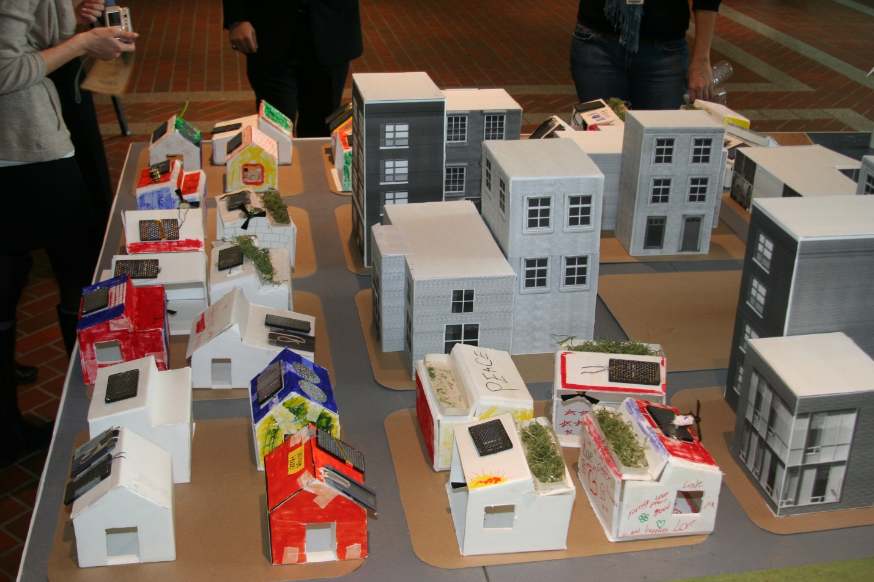

In 2012, the theme was Robotic technology and the students built model robots using [Lego Mind Storm kits](http://www.legoeducation.us/eng/product/ev3_core_set/2578). These robots were programmed to “Race to the PTO.” In 2013, the theme was 3-D printing technology.

Which schools have been involved in E-Week?

Since 2011, students from the ninth grade campus of T.C. Williams High School, called Minnie Howard, have consistently attended our E-Week events. In 2011, students from Whittier Elementary School were invited to attend; however, they canceled at the last minute. In 2012, students from Eastern High School attended the E-Week program while students from National Collegiate Prep attended in 2013.

How many students can we expect?

We are targeting to host up to 60 students. In the past, we have had about 30-40 students come the day of the event.